SB/10-
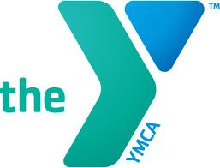
23rd General Assembly
of the
Tennessee YMCA Middle School
Youth in Government

SENATE

A template for this bill form is available on our website at www.tennesseeyig.org in the Download Forms section. Students can type directly onto the template, which will generate line numbers, proper heading, etc. Then they can simply print out their bill.

Sponsors:

Committee:
School:

